**Online Banking System Testing**

**Test Plan**

**Overview:**

**Project Name**: Online Banking System Testing  
**Objective**: Validate the functionality, security, and usability of the online banking system.  
**Scope**:

* Login and account access
* Fund transfers (internal and external)
* Bill payments
* Transaction history

**Test Environment:**

* Browsers: Chrome, Edge, Firefox
* Devices: Desktop, Mobile
* Tools: JIRA, Zephyr, BrowserStack

**Test Deliverables:**

* Test Cases
* Test Execution Report
* Defect Log

**Risks:**

* Frequent changes in banking regulations.
* Limited time for performance testing under heavy user load.

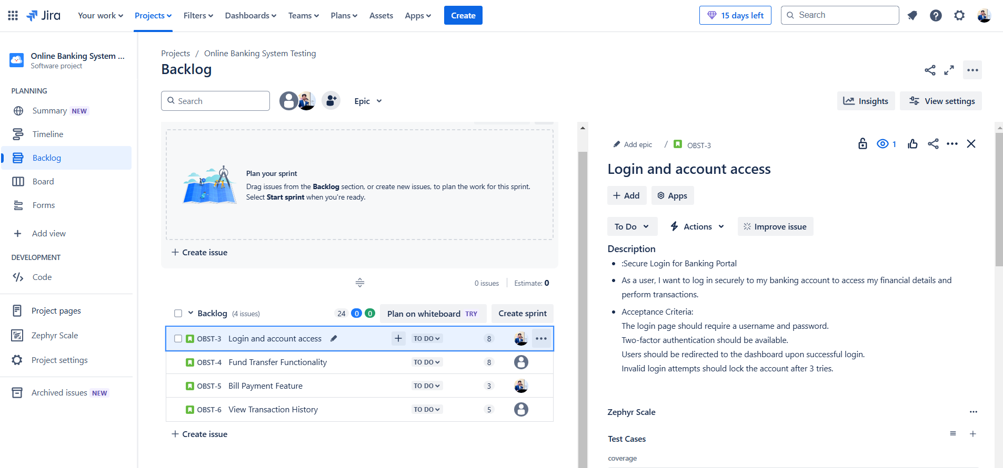

* QBST-3 **Login and account access**

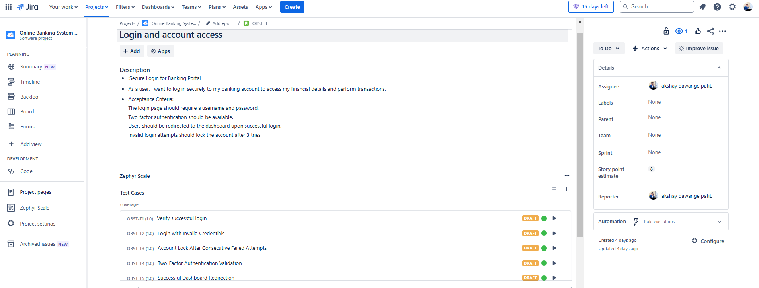

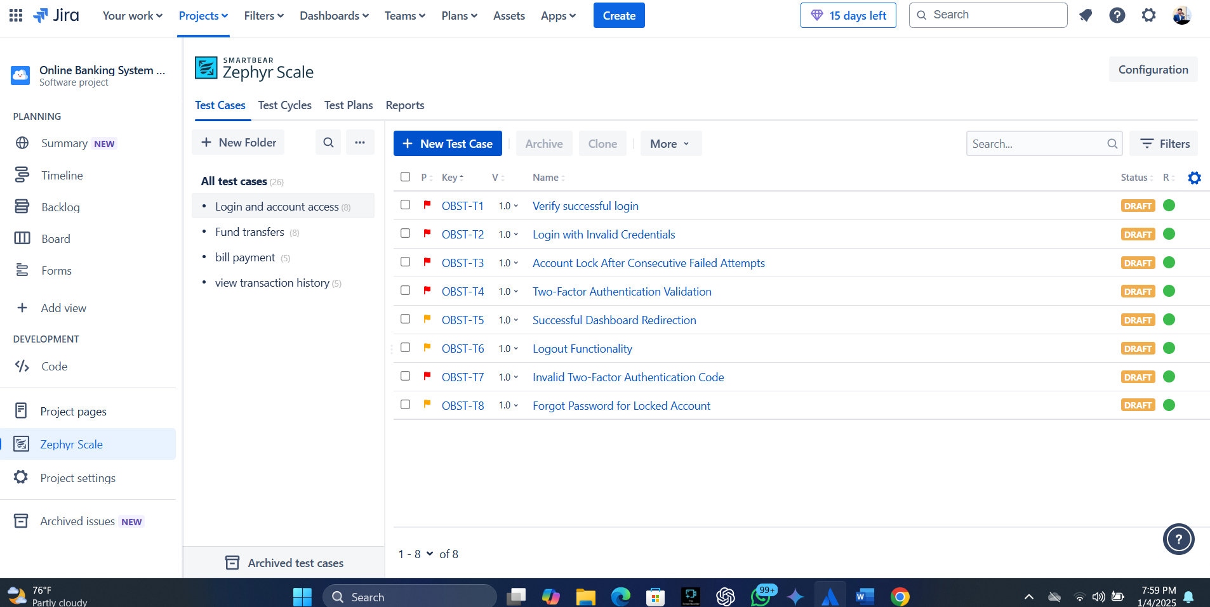

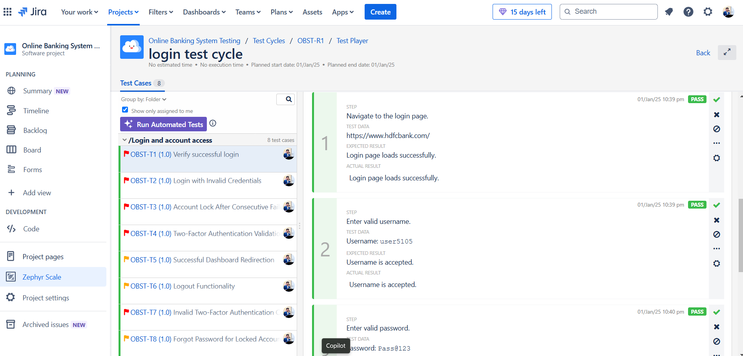

QSBT-4 Fund Transfer Functionality.

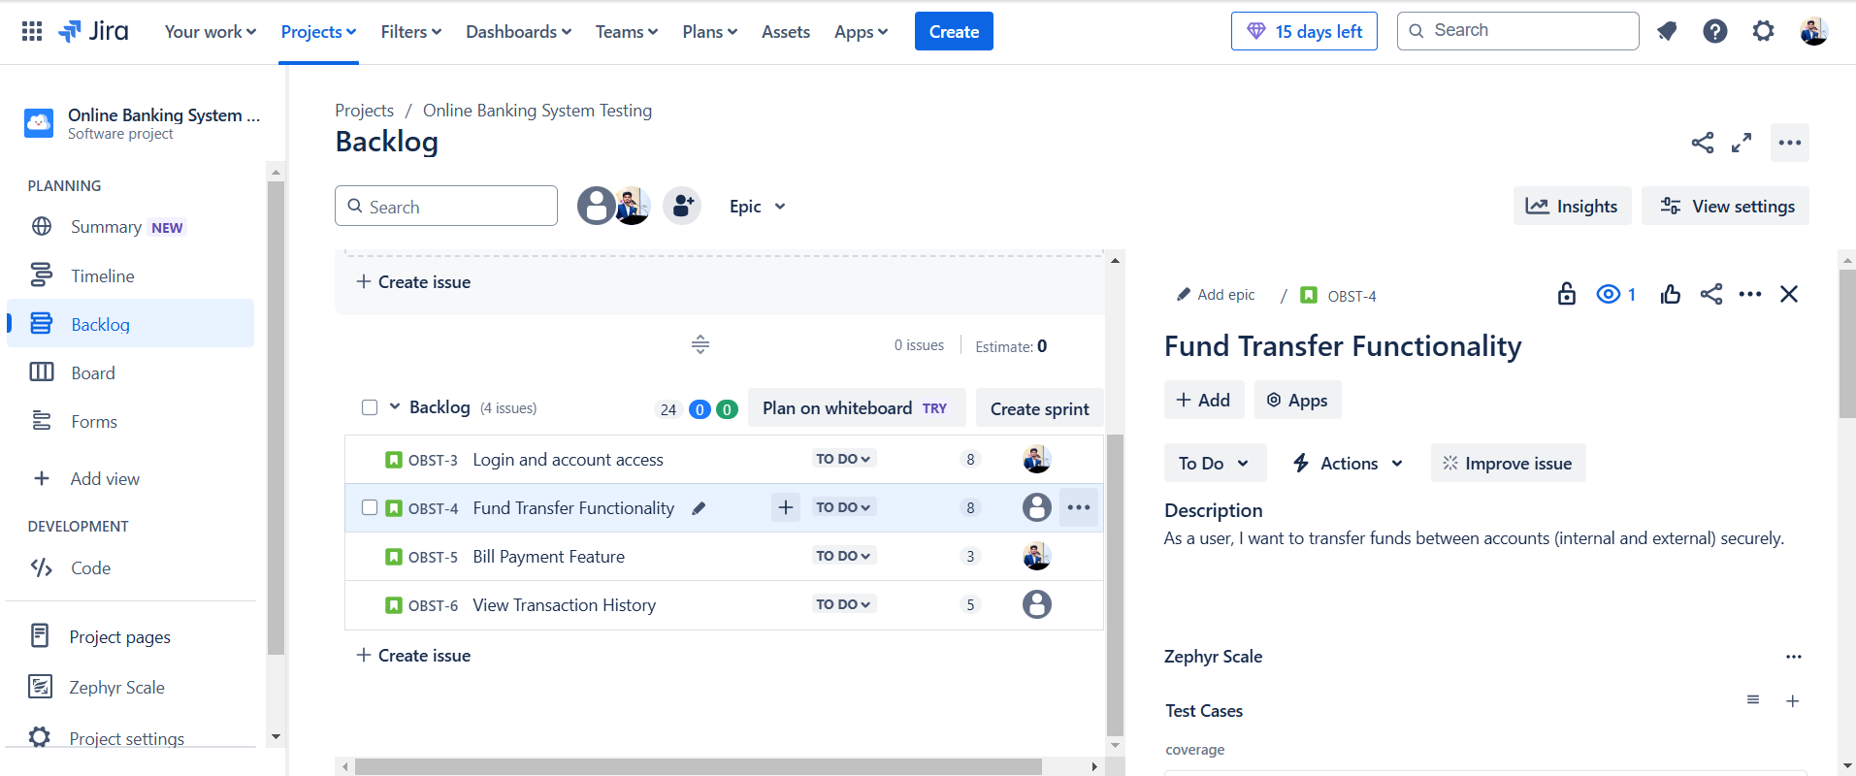

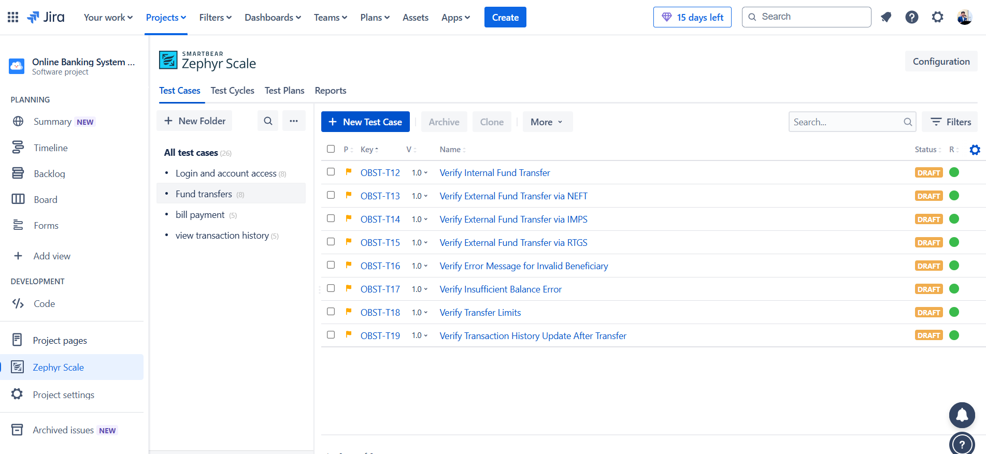

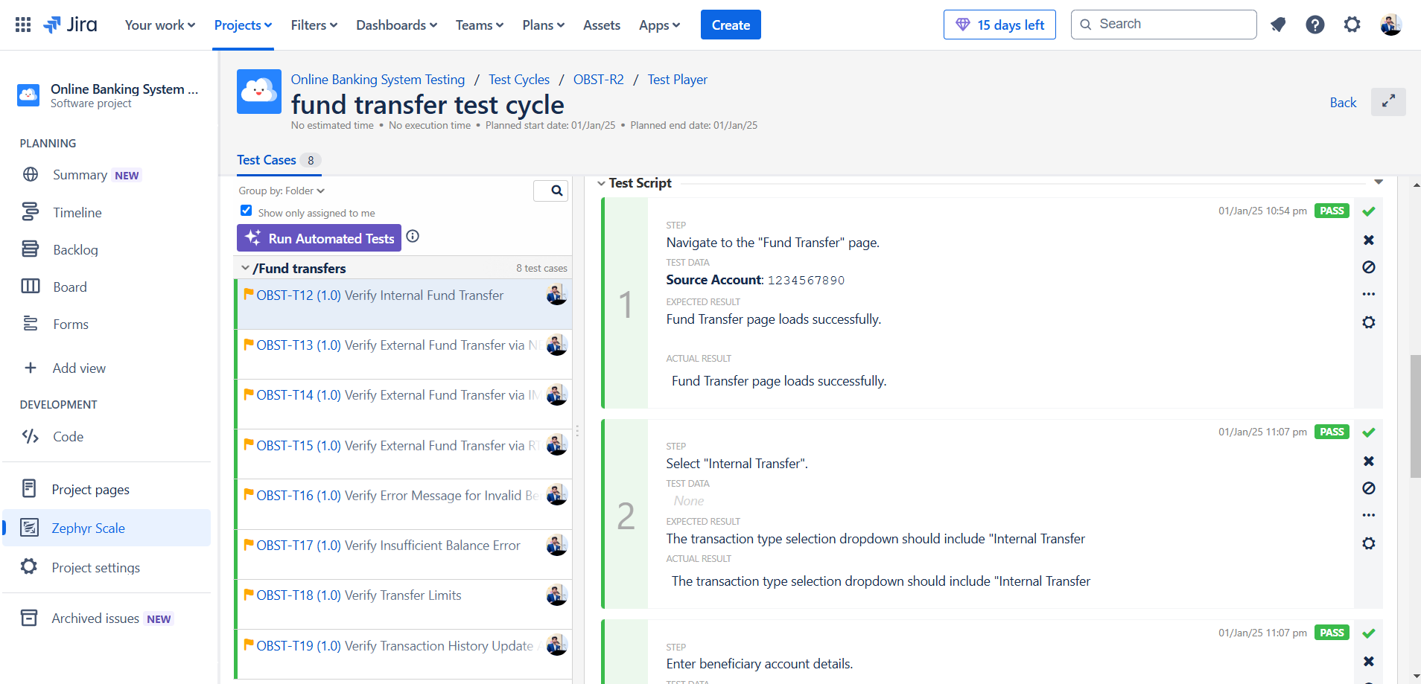

QBST-5 **Bill Payment Feature.**

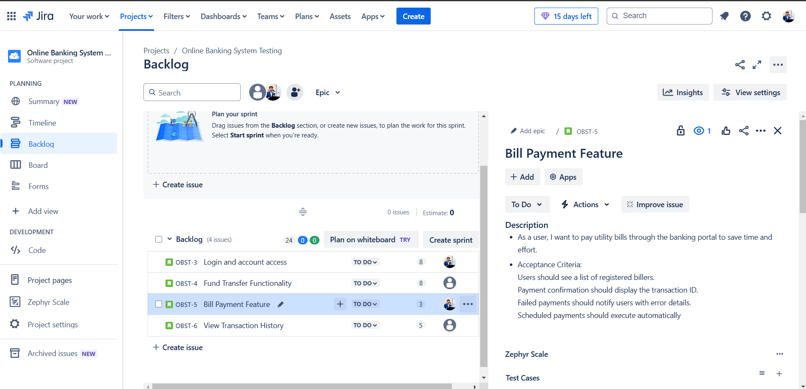

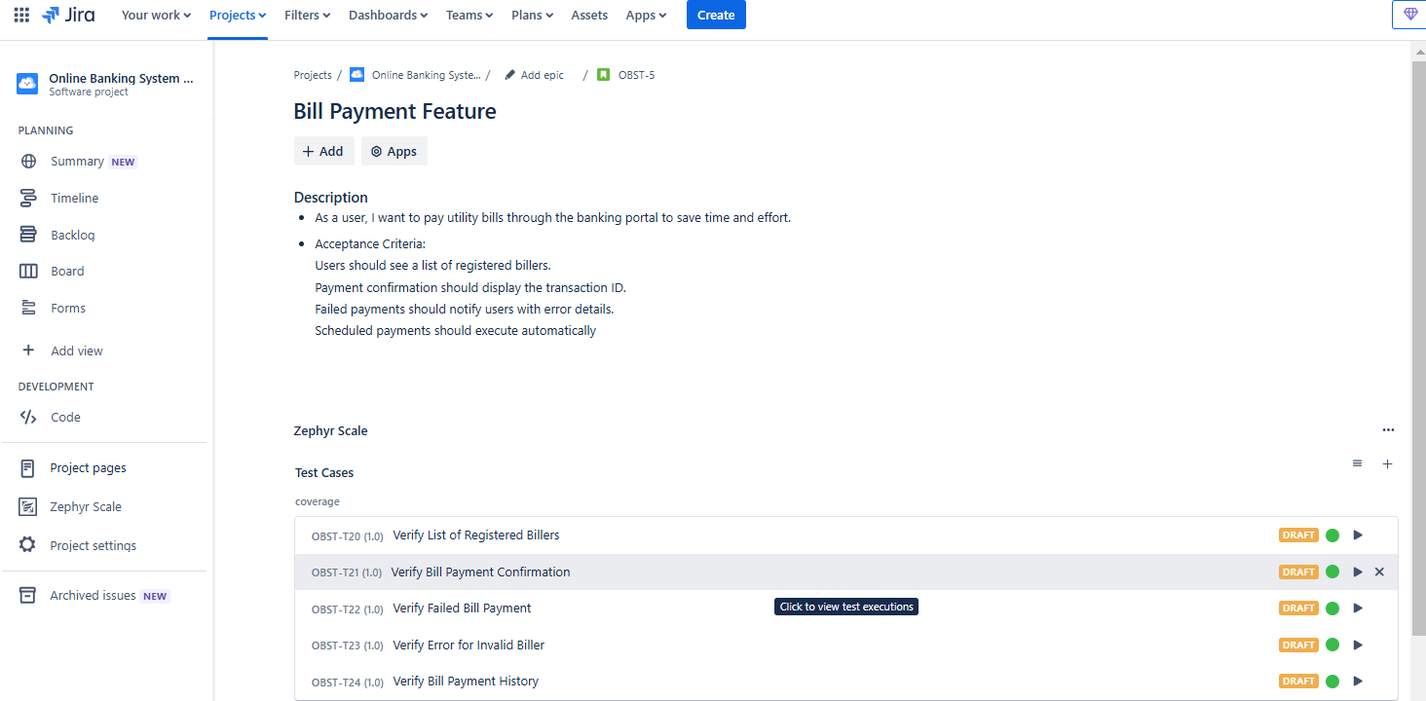

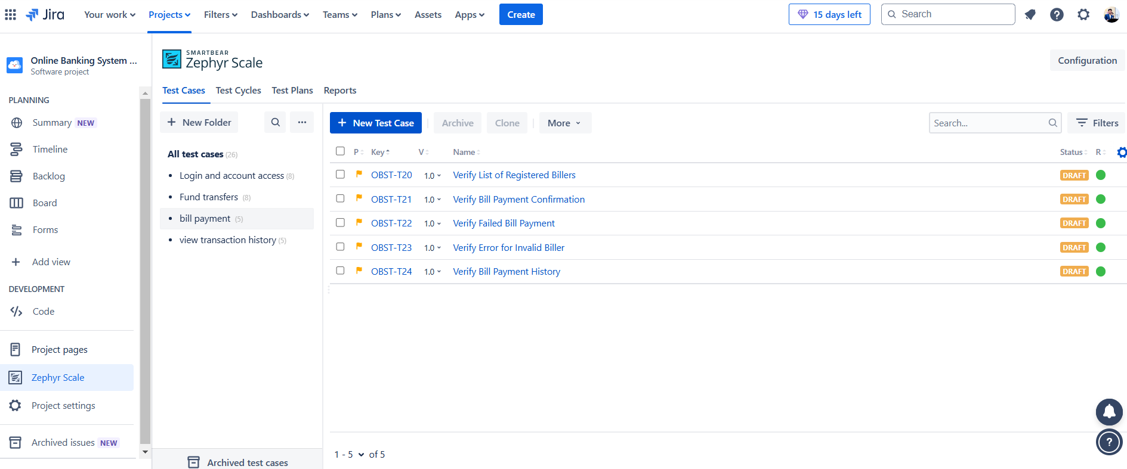

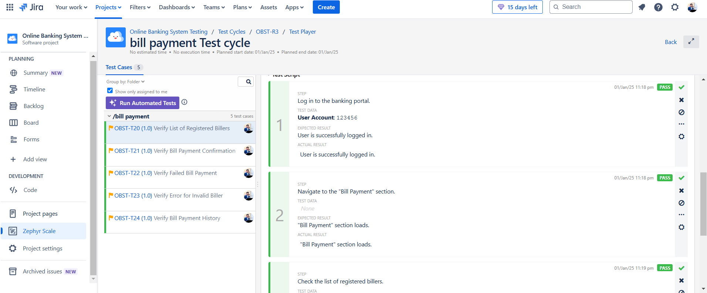

QBST-6 **View Transaction History.**

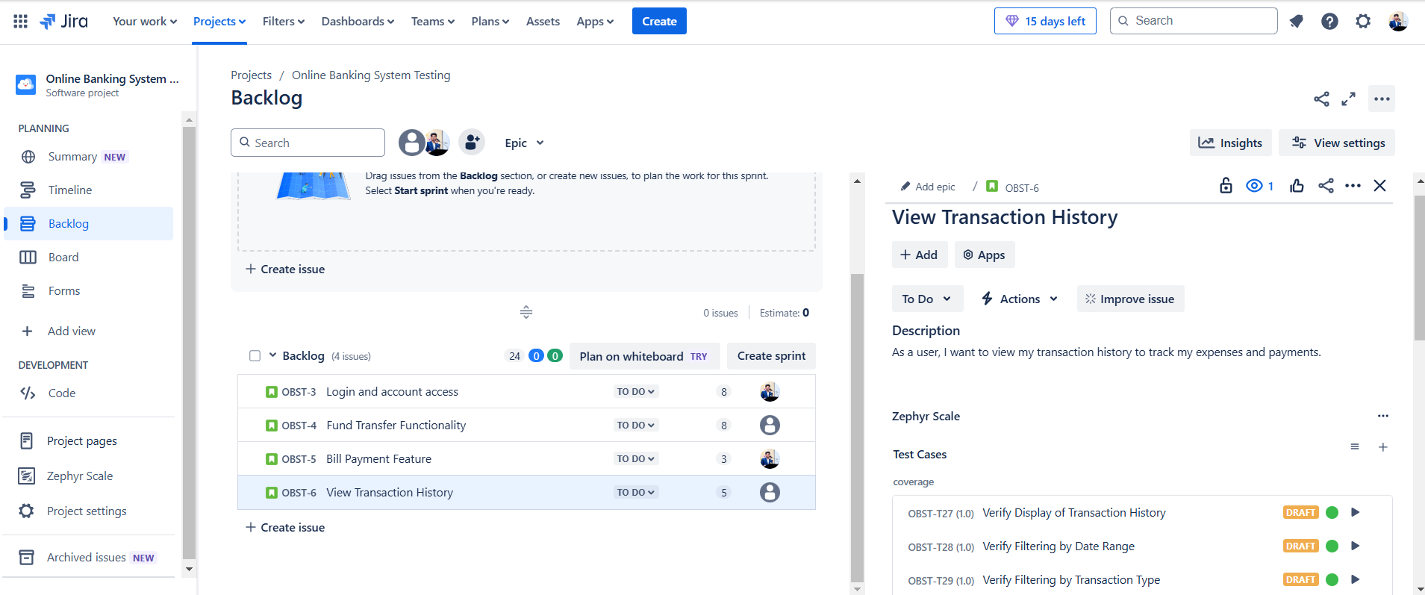

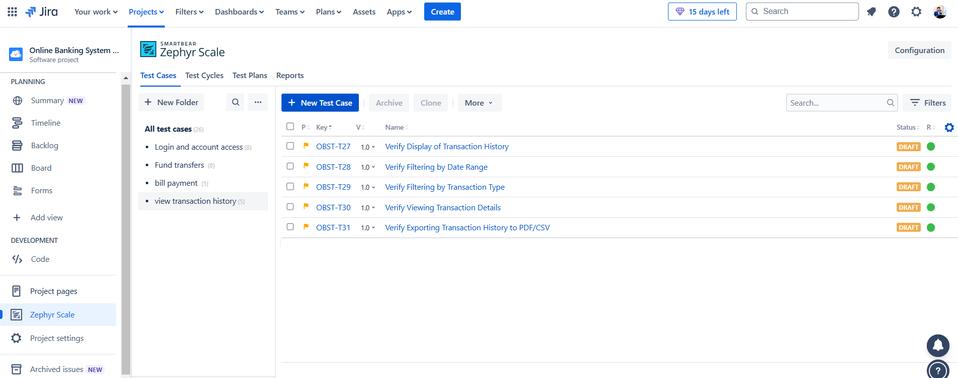

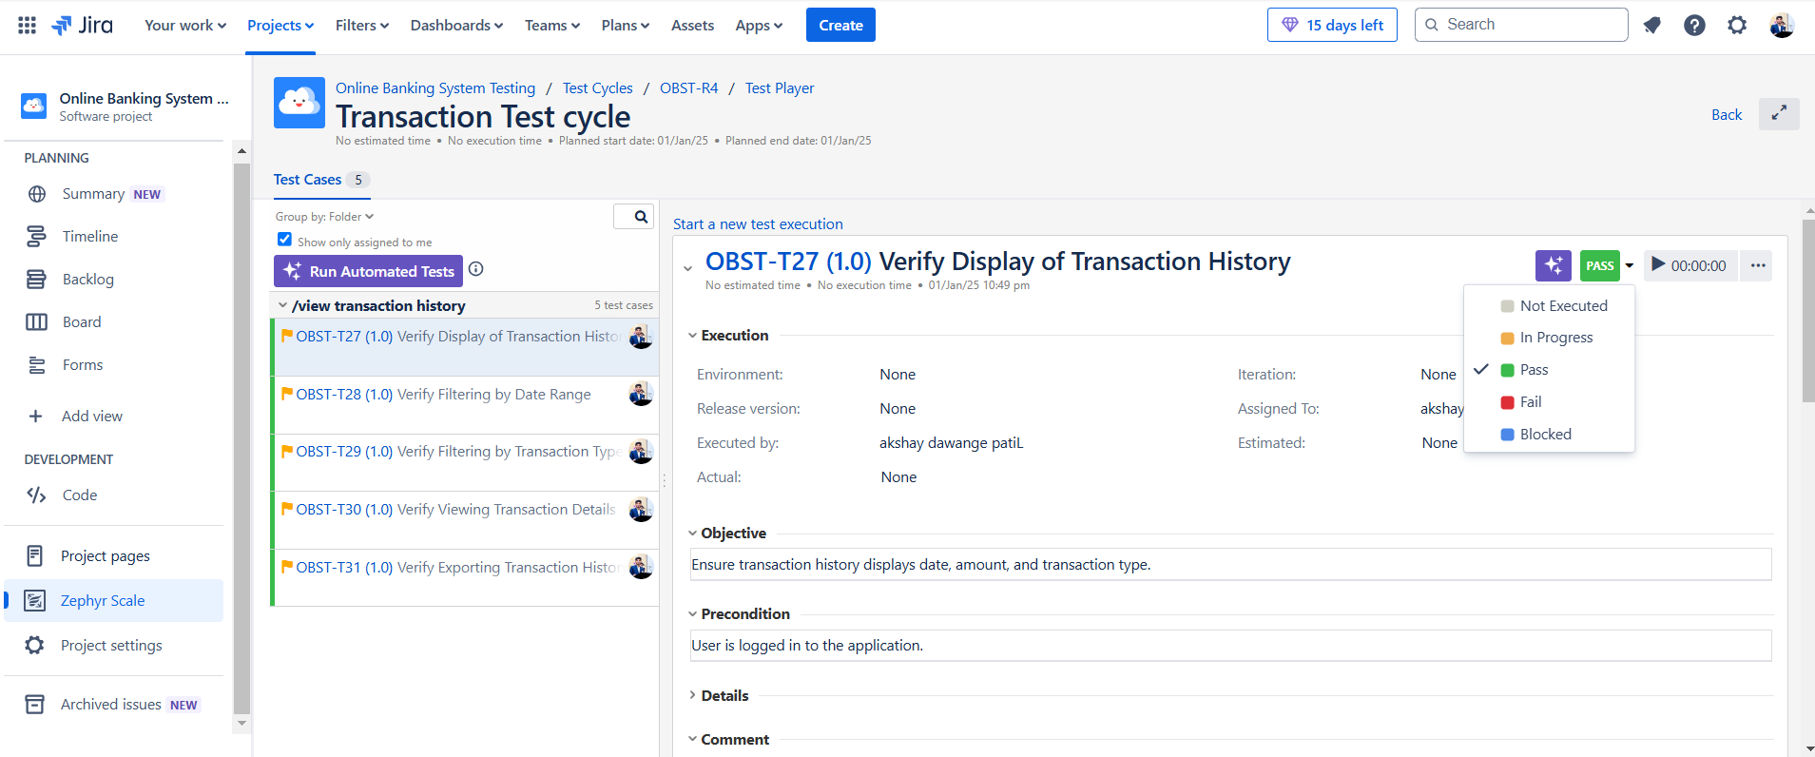

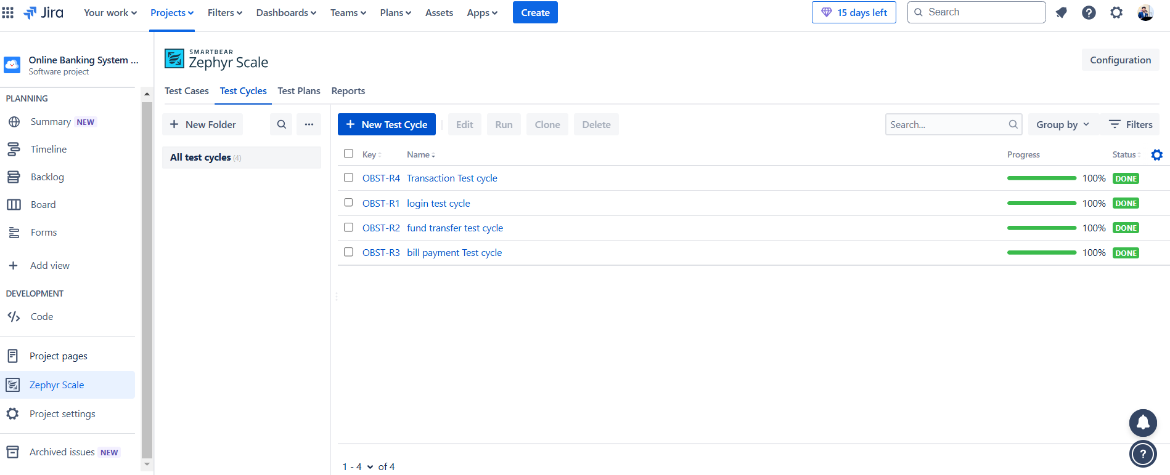

**Requirement Traceability Matrix (RTM)**

| **Requirement ID** | **Requirement Description** | **Test Case ID** | **Test Status** |
| --- | --- | --- | --- |
| R1 | Login with valid credentials | TC1 | Passed |
| R2 | Transfer funds to an external account | TC2 | Passed |
| R3 | Pay utility bills | TC3 | Passed |
| R4 | View transaction history | TC4 | Passed |

**Test Cases**

**Functional Test Cases**

| **Test Case ID** | **Test Case Description** | **Steps** | **Expected Result** | **Status** |
| --- | --- | --- | --- | --- |
| TC1 | Login with valid credentials | 1. Open banking website 2. Enter valid username and password 3. Click Login | User is redirected to the dashboard | Passed |
| TC2 | Transfer funds to an external account | 1. Navigate to Fund Transfer 2. Enter beneficiary details 3. Enter amount 4. Confirm transfer | Funds are successfully transferred | Passed |
| TC3 | Pay utility bills | 1. Navigate to Bill Payments 2. Select utility provider 3. Enter account details 4. Confirm payment | Payment is processed successfully | Passed |
| TC4 | View transaction history | 1. Navigate to Transaction History 2. Filter by date range | Transactions are displayed | Passed |

**Security Testing Checklist**

| **Area** | **Security Test** | **Result** |
| --- | --- | --- |
| Authentication | Test login with invalid credentials | Passed |
| Authorization | Test restricted pages without login | Passed |
| Data Protection | Verify sensitive data is encrypted (e.g., passwords) | Passed |
| Session Management | Test session timeout and cookie expiration | Passed |